Non USD Currency Testing
Product/Pricing Configuration
- Tier based pricing (attribute based): BeSECURE – Premised-Based VM-BSL-RSL-BESEPB
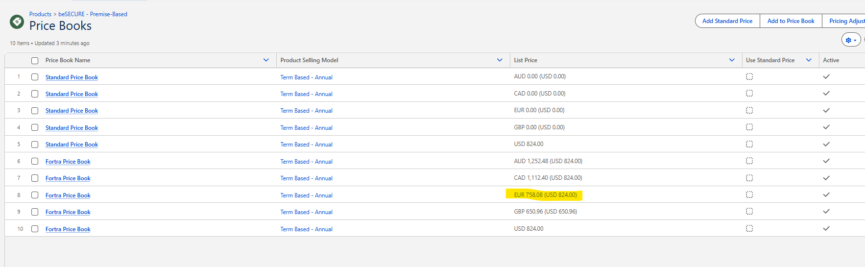
- Server Type Discount pricing: Advanced Authentication Modes - GS-GSE-NRPS-AAMP

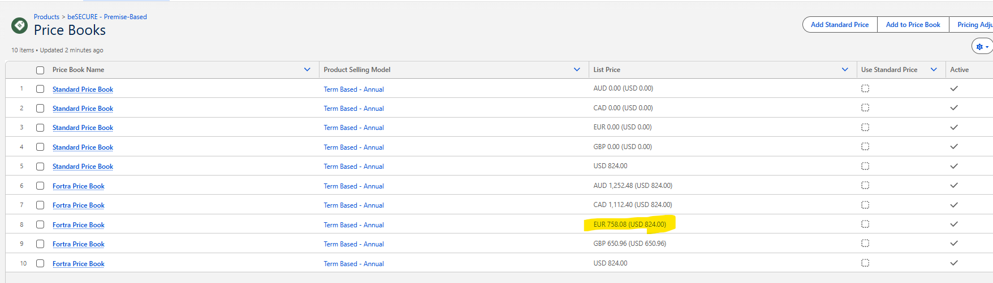
- Attribute-based pricing: VM Analyst - VM-VLM-NRSU-VMA
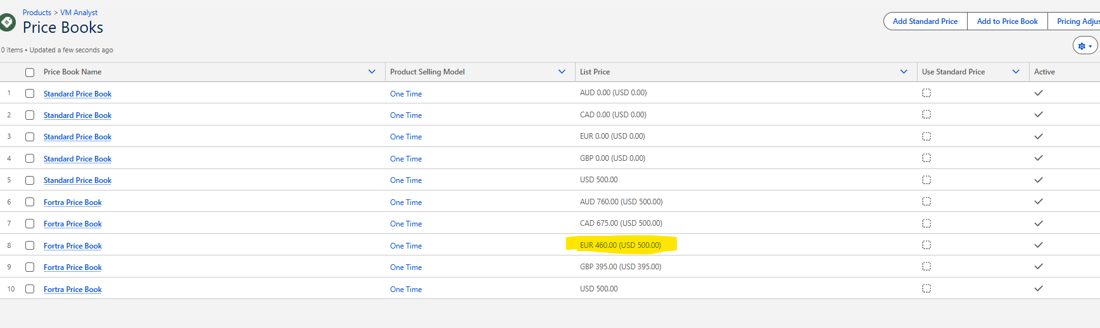

Tiered pricing (Attribute_Tier_Pricing_Storage based): Click and Launch Security Awareness Training - All Star - HRM-HRM-RSL-CLSAAS
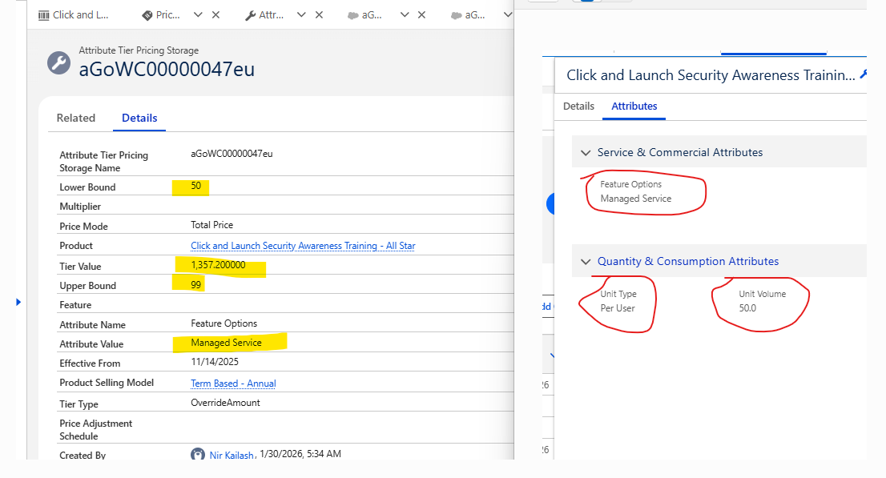
Auto-add Maintenance: Powertech Identity & Access Manager (BoKS) - PIA-PIA-NRPS-PIAP auto adds Powertech Identity & Access Manager (BoKS)-NewMaintenance - PIA-PIA-RNM-PIAMBK
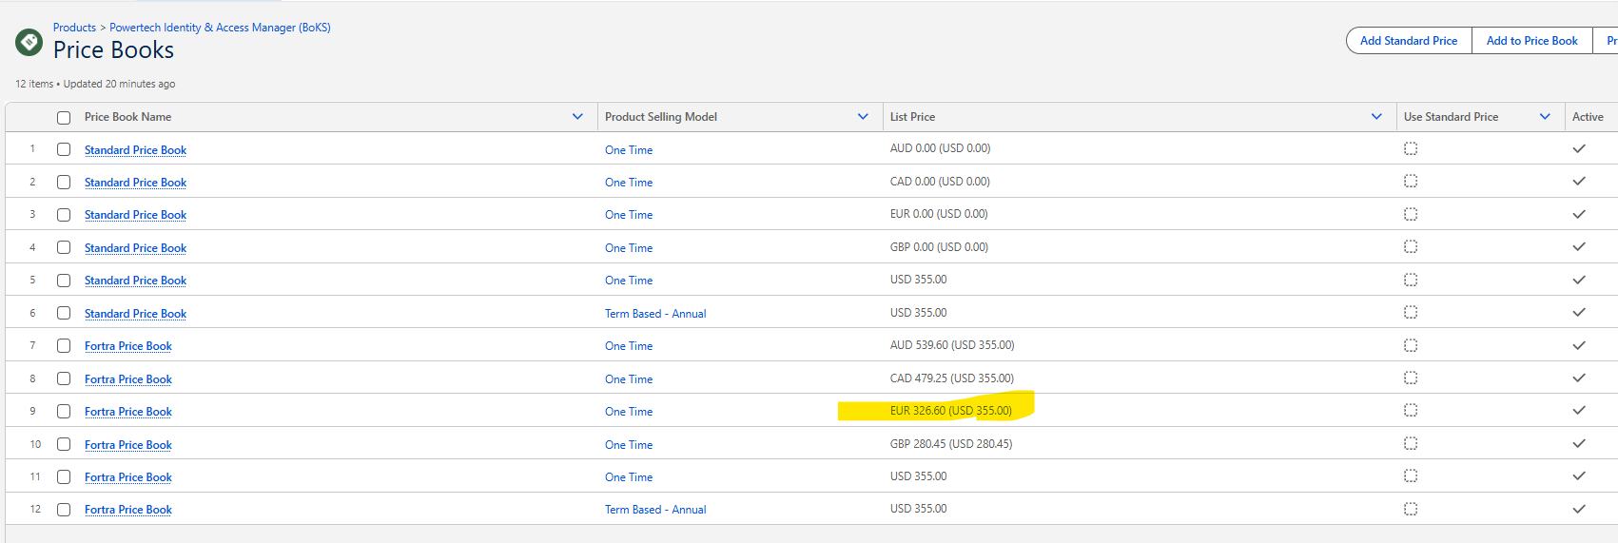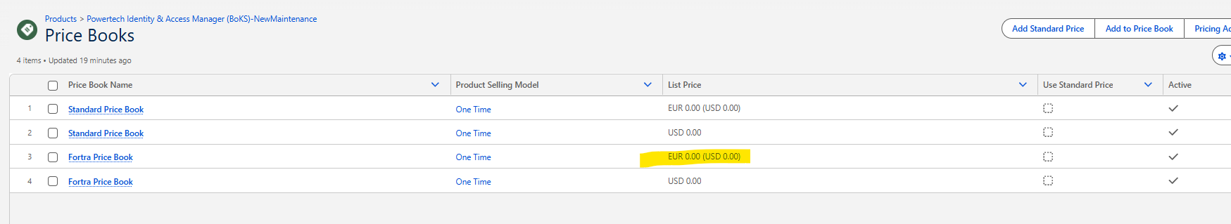

Test Quote
- Q-Wren - Test Currencies-2026-06-09
https://fortra--uat.sandbox.lightning.force.com/lightning/r/Quote/0Q0WC0000036xy90AA/view
- Line 1 – Tiered pricing product shows correct List Price in Euro, but the tiered price in USD is shown for Net Unit, Net Total, Subtotal and Total. Is has a Euro symbol but it is the USD price.
- Line 2 – The List Price shows the correct Euro price of this product, but the Subtotal shows the USD price and the Net Unit, Net Total and Total price are 50% of the USD price not the Euro price.
- Line 3 – The List Price is the correct Euro price for the base product, but the attribute-based price in Net Unit, Net Total, Subtotal and Total is the USD price for the configured attributes.
- Line 4 – The List Price is the Euro price book price for this product, but the Subtotal is the USD price for the configured quantity of 50. Net Unit, Net Total and Total all show $0. The Attribute Tier Pricing Storage records are all set to USD, but the AttributeVolumePricingPrehook does not appear to be including currency in the pricing tier lookup.
- Auto-add maintenance products – These are not show in the quote screenshot because they fail to be added to the quote with the following error:
